

SIMATS ENGINEERING

Saveetha Institute of Medical and Technical Sciences
Chennai- 602105

Student Name: S.Mythili Reg. No.:192411250
Course Code: CSA1711 Slot: C
Course Name: Artificial intelligence
Course Faculty: Dr. K. Krishna Kumar
Project Title: AI - Based crop disease detection
Module Photographs:
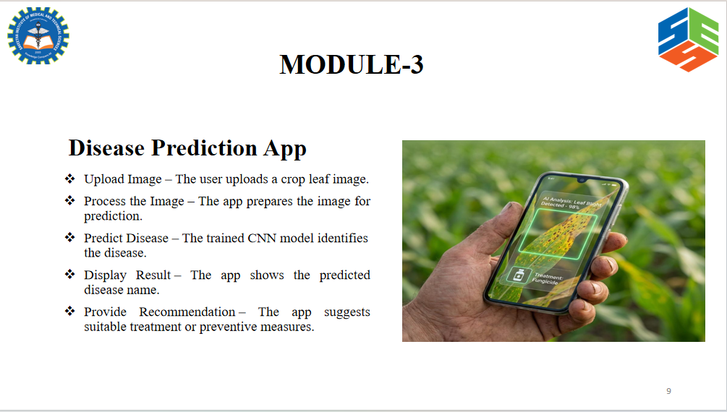 | 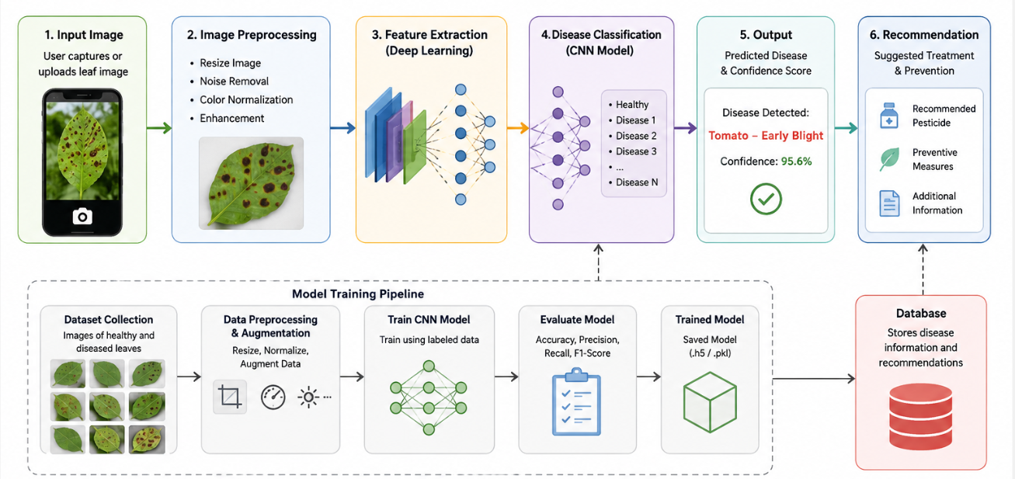 | 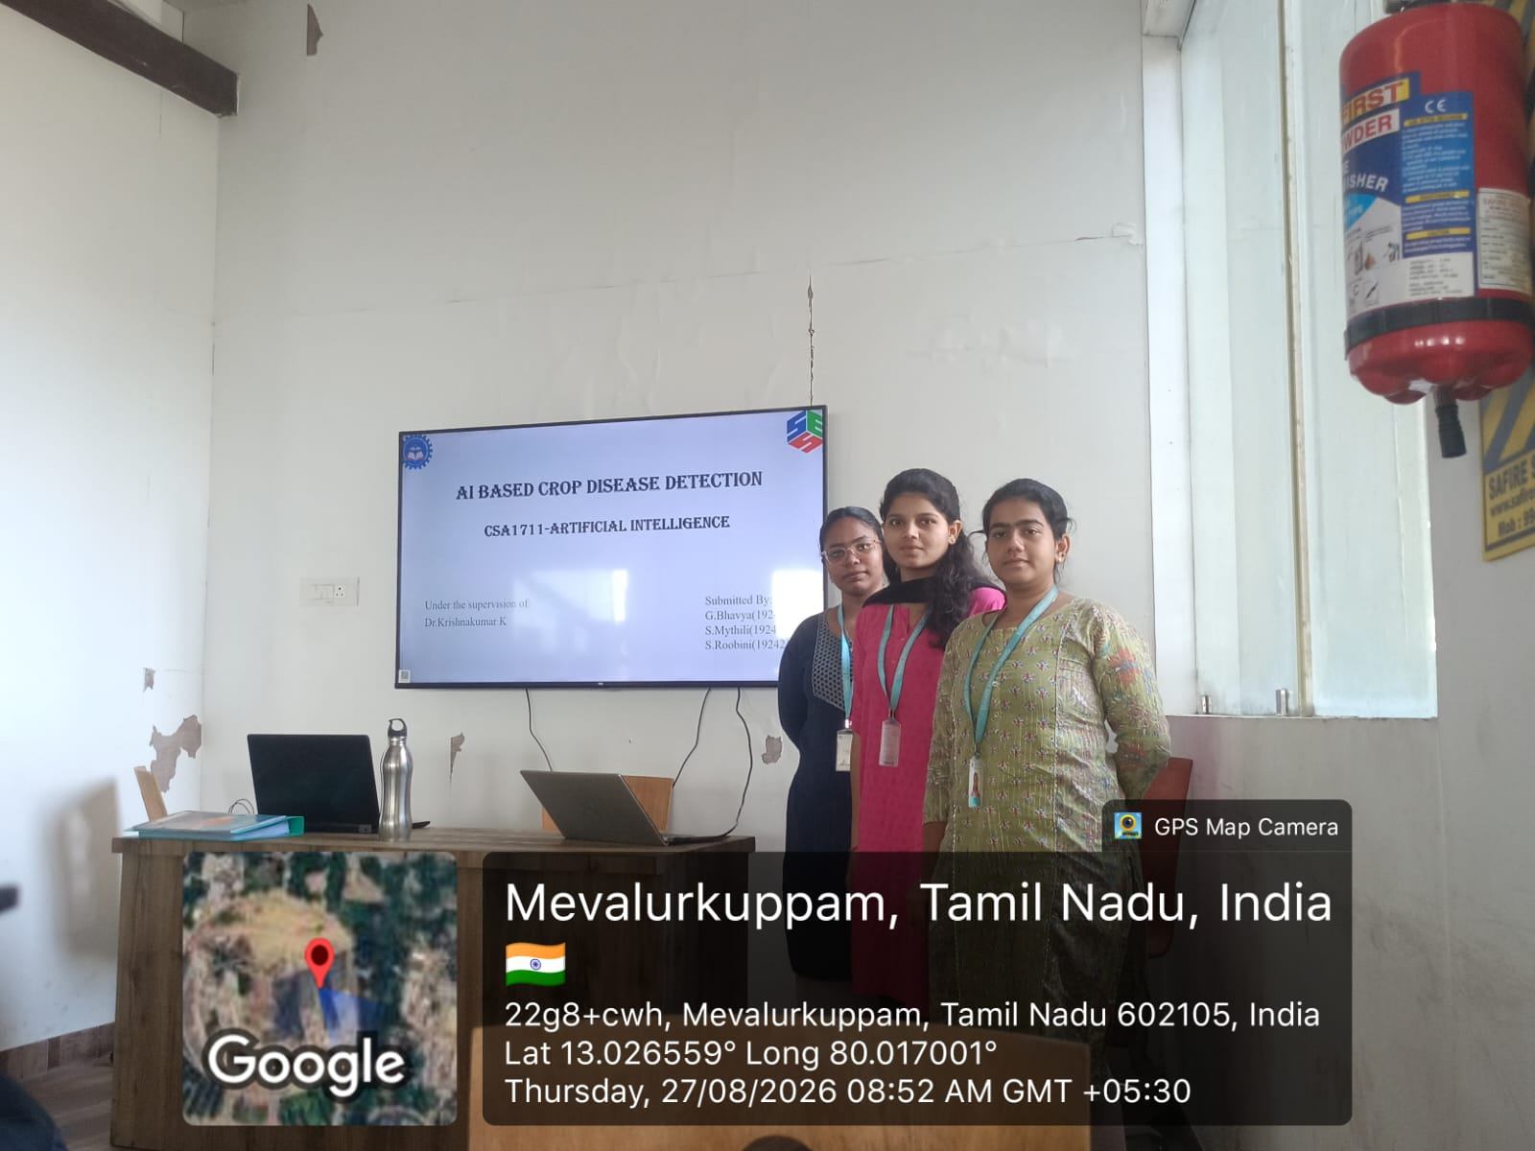
Project Description: MODULE 3: The Disease Prediction App
The Disease Prediction App provides a simple web interface where users can upload an image of a plant leaf for disease detection. The uploaded image is preprocessed and given to the trained CNN model, which analyzes the leaf and predicts the crop name, disease name, and healthy or diseased status. The application also displays the prediction confidence and provides basic information and suggested guidance about the detected disease. The results are presented in a clear and user-friendly format. This module connects the trained AI model with the web application, making the disease detection system easy for users to access and understand.
The application provides an image preview before prediction. It can maintain a history of previous predictions for reference. The system displays the top predicted disease based on the model's output probability. It also provides a simple and responsive interface that can be accessed from different devices.

Student Signature Guide Signature

